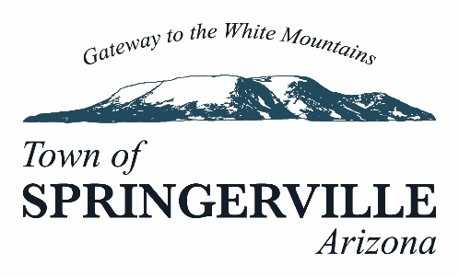
----------------------------------------------------------------------------------------------------------------------
418 E. Main Street, Springerville, AZ 85938• Phone (928)333-2656

Notice of Sealed Bid Auction – Mobile Homes

The Town of Springerville is accepting separate sealed bids for the sale of the following mobile homes:
1976 Custom Crest Mobile Home
Size: 24' x 60'
Minimum Bid: $5,000 or best offer
1987 Coastal Modular West, Inc. Mobile Home
Size: 28' x 68'
Minimum Bid: $5,000 or best offer
Both mobile homes will be sold "AS IS" and must be removed from the property at the purchaser's expense within thirty (30) days of the date of sale.
Bidders are invited, urged, and cautioned to inspect the mobile homes prior to submitting a bid. Failure of any bidder to inspect or to be fully informed as to the condition of all or any portion of the mobile homes shall not constitute grounds for any claim, demand for adjustment, or withdrawal of a bid after the bid opening.
Sealed bids will be received by the Town of Springerville at the Springerville Town Hall, 418 E Main Street, Springerville, Arizona 85938 until July 28, 2026, at 11:00 a.m. (MST) and then opened and read aloud. Sealed bids received after that time will not be accepted. Springerville Council will review bids on August 10, 2026. The Town of Springerville reserves the right to reject any proposals.

For additional information or to schedule an inspection, please contact:
Kelsi Miller
Town of Springerville
Phone: (928) 333-2656 Ext. 224
White Mountain Independent
Published: June 30, July 7, July 14, 2026

